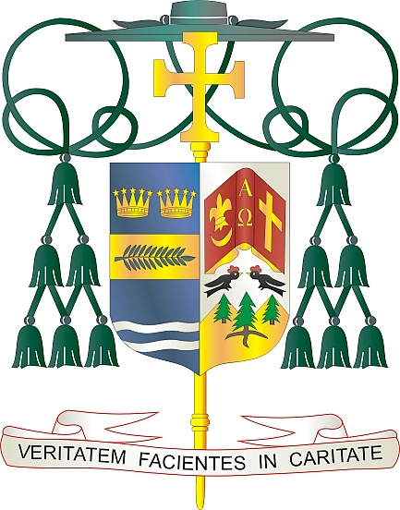
Office of
THE BISHOP

9995 North Military Trail • P.O. Box 109650
Palm Beach Gardens, Florida 33410-9650

(561) 775-9595 Fax (561) 775-7035

Diocese of Palm Beach

February 12, 2022

Dear Sisters and Brothers in Christ:

Next weekend, February 19th and 20th, the Diocese of Palm Beach will have a second collection to support our local priests who have retired. Many of our retired priests, because of age or infirmity, are no longer able to publicly assist at Mass, yet are nonetheless integral parts of our diocesan family. In addition to supporting them financially, we also ask that you pray for our retired priests during this same weekend.

The money raised from this collection helps support the nearly 40 retired priests within our five counties. These priests, who have blessed us with their joyful service to the Lord, are valued members of our diocese now and always. Your support of our retired priests, through your prayers and generosity, is greatly appreciated. Thank you in advance for allowing them to continue to be faithful stewards of God’s mysteries.

With gratitude for your continued generosity and every prayerful wish, I am

Sincerely yours in Christ,
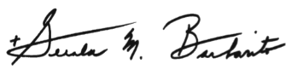

Most Reverend Gerald M. Barbarito
Bishop of Palm Beach

NOTE TO PASTORS: IT IS REQUIRED THAT YOU PUBLISH THIS LETTER IN THE PARISH BULLETIN AS A HALF-PAGE OR FULL-PAGE LETTER THE WEEKEND OF FEBRUARY 12/13, 2022. THE COLLECTION WILL TAKE PLACE FEBRUARY 19/20, 2022. YOU ARE WELCOME TO READ THE LETTER TO PARISHIONERS, POST THIS LETTER ON SOCIAL MEDIA, AND ON YOUR WEBSITE IN ADDITION TO HAVING IT PRINTED IN THE BULLETIN.

