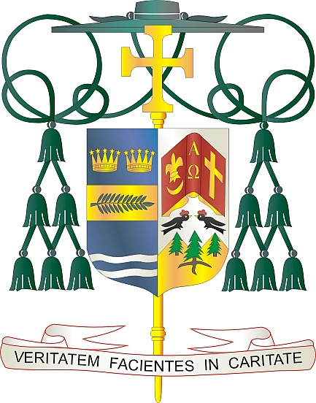
Office of
THE BISHOP

9995 North Military Trail • P.O. Box 109650
Palm Beach Gardens, Florida 33410-9650

(561) 775-9595 Fax (561) 775-7035

Diocese of Palm Beach

June 5, 2021

Dear Sisters and Brothers in Christ:

Next weekend, June 12/13 the Diocese of Palm Beach will have a special collection for two causes: Black & Indian Missions and the Catholic Home Missions.

The Black and Indian Mission Collection exists to assist African American and Native American Catholic communities throughout the United States. The United States Catholic Bishops established Black and Indian Mission Office to minister to provide much needed financial assistance to dioceses across the country to operate schools, parishes, and other missionary services that build the Body of Christ in Native American, Alaska Native, and Black Catholic communities.

The Catholic Home Missions portion of the collection primarily supports home mission dioceses, that is, those dioceses in the United States that are unable to offer their people the basic pastoral ministries of word, worship, and service without outside help. All too often we associate missions with foreign countries, but in our own great nation we have pockets of extreme poverty that rely on us for support.

With gratitude for your continued generosity and every prayerful wish, I am

Sincerely yours in Christ,
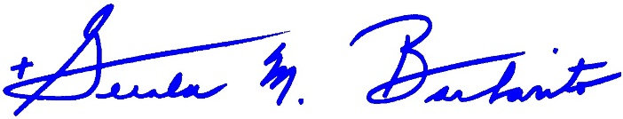
Most Reverend Gerald M. Barbarito
Bishop of Palm Beach

NOTE TO PASTORS: IT IS REQUIRED THAT YOU PUBLISH THIS LETTER IN THE PARISH BULLETIN AS A HALF PAGE OR FULL-PAGE LETTER THE WEEKEND OF JUNE 5/6, 2021. THE COLLECTION WILL TAKE PLACE JUNE 12/13, 2021. YOU ARE WELCOME TO READ THE LETTER TO PARISHIONERS, POST THIS LETTER ON SOCIAL MEDIA, AND ON YOUR WEBSITE IN ADDITION TO HAVING IT PRINTED IN THE BULLETIN.

