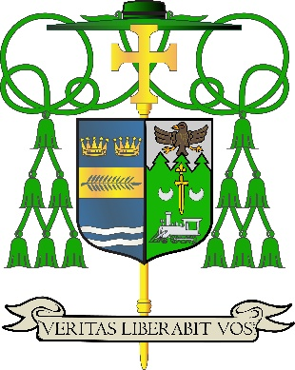

Office of
THE BISHOP

9995 North Military Trail • P.O. Box 109650
Palm Beach Gardens, Florida 33410-9650

(561) 775-9595 Fax (561) 775-7035

Diocese of Palm Beach

February 27, 2026

Dear Sisters and Brothers in Christ:

Next weekend, March 7/8, parishes in the Diocese of Palm Beach will take up the annual second collection for education of seminarians and formation of priests. The funds raised in this collection are used to cover the cost of tuition, housing, education and pastoral training of our eight seminarians. Those expenses are significant and rising all the time.

The yearly cost of tuition for one seminarian is now about $25,000, and the yearly room and board for one seminarian is $15,000. Thanks to your assistance, our seminarians are able to journey in faith without being financially burdened and can devote themselves fully to priestly formation. Since the last collection, we celebrated the ordinations of Father Jude Okeke in May 2025 and Father Jedidiah Preble in January 2026.

St. Paul said, “I am confident of this, that the one who began a good work in you will continue to complete it until the day of Christ Jesus” (Phil 1:6). May the excellent work of forming our seminarians, along with your fervent prayers, pay abundant dividends with an increase in vocations for many years to come.

With gratitude for your continued generosity and every prayerful wish, I am

Sincerely yours in Christ,
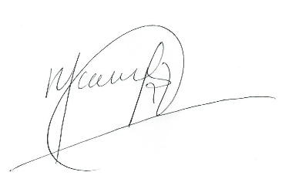

Most Reverend Manuel de Jesús Rodríguez
Bishop of Palm Beach

NOTE TO PASTORS: IT IS REQUIRED THAT YOU PUBLISH THIS LETTER IN THE PARISH BULLETIN AS A HALF-PAGE OR FULL-PAGE LETTER THE WEEKEND OF FEBRUARY 28/MARCH 1, 2026. THE COLLECTION WILL TAKE PLACE MARCH 7/8, 2026. YOU ARE WELCOME TO READ THE LETTER TO PARISHIONERS, POST THIS LETTER ON SOCIAL MEDIA, AND ON YOUR WEBSITE IN ADDITION TO HAVING IT PRINTED IN THE BULLETIN.

