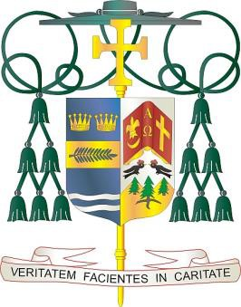Diocese of Palm Beach

9995 North Military Trail • P.O. Box 109650 Palm Beach Gardens, Florida 33410-9650

(561) 775-9595 Fax (561) 775-7035

September 5, 2025

Dear Sisters and Brothers in Christ:

Office of THE BISHOP

Next weekend, September 13/14, parishes in our Diocese will collect funds to aid our Catholic Charities Respect Life Ministry and support three local faith communities that serve many migrant families.

Half of the collection will support pro-life projects that raise awareness in such areas as abortion, physician-assisted suicide/euthanasia, the death penalty, end-of-life care and bioethics. The Respect Life Ministry honors the dignity and sanctity of human life by leading and advocating for prayer, teaching, legislative action and parish outreach through implementation of the Pastoral Plan for Pro-Life Activities of the U.S. Conference of Catholic Bishops.

The collection also will aid the parishes of St. Philip Benizi in Belle Glade, St. Mary in Pahokee and Holy Cross in Indiantown with their diverse pastoral and social needs. Their large numbers of migrant parishioners present unique challenges, and your help will make a great difference in many lives. Please consider a generous, compassionate response to assist these vital Catholic initiatives.

With gratitude for your continued generosity and with every prayerful wish, I am

Sincerely yours in Christ,

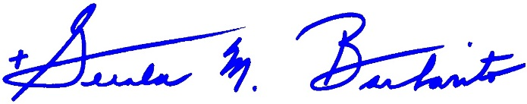

Most Reverend Gerald M. Barbarito Bishop of Palm Beach

**NOTE TO PASTORS: IT IS REQUIRED THAT YOU PUBLISH THIS LETTER IN THE PARISH BULLETIN AS A HALF PAGE OR FULL-PAGE LETTER THE WEEKEND OF SEPTEMBER 6/7, 2025. THE COLLECTION WILL TAKE PLACE SEPTEMBER 13/14, 2025. YOU ARE WELCOME TO READ THE LETTER TO PARISHIONERS, POST THIS LETTER ON SOCIAL MEDIA, AND ON YOUR WEBSITE IN ADDITION TO HAVING IT PRINTED IN THE BULLETIN.**