Diocese of Palm Beach
9995 North Military Trail • P.O. Box 109650
Palm Beach Gardens, Florida 33410-9650

(561) 775-9595 Fax (561) 775-7035
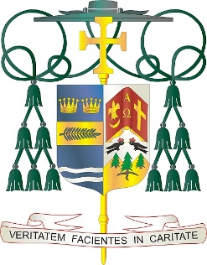
Office of
THE BISHOP

October 30, 2025

Request from Bishop Barbarito regarding prayers and support
for those affected by Hurricane Melissa

“We join in fervent prayer for all those so adversely affected by the catastrophic hurricane, Melissa, in the Caribbean, which includes Jamaica, Cuba and Haiti.

The strongest storm of the season has left in its passage a loss of life and affected the living conditions of so many of our brothers and sisters south of our shores.

We pray that hope may sustain those affected in the recovering and rebuilding that will need to take place. Financial assistance can be made directly to Catholic Relief Services at https://www.crs.org/donate/hurricane-melissa.”

###

