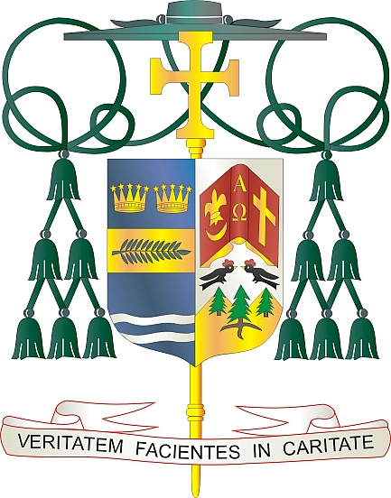
Office of
THE BISHOP

9995 North Military Trail • P.O. Box 109650
Palm Beach Gardens, Florida 33410-9650

(561) 775-9595 Fax (561) 775-7035

Diocese of Palm Beach

November 5, 2022

Dear Sisters and Brothers in Christ:

Next weekend our diocese will have a second collection for the Catholic Campaign for Human Development (CCHD). The CCHD has served diverse communities across the United States for more than 50 years by empowering local leaders to advocate for jobs and educational opportunities, for affordable health care and housing access, and for the rights of vulnerable communities.

Twenty-five percent of the donations collected next weekend, Nov. 12-13, will stay in our diocese and directly benefit poor and marginalized individuals. Working in partnership with Catholic Charities, the Diocese of Palm Beach makes the funds available to small, grassroots, local and neighborhood efforts that empower the poor as stakeholders and decision makers in order to change their communities. We know that 38 million people live in poverty across the United States. Our diocese is blessed with many small, dedicated, grass-roots efforts that work to improve the conditions of the more than 260,000 individuals in our diocese who live in poverty. Your support of this important collection empowers them and helps create meaningful change.

Your spiritual and financial support of the CCHD is an act of solidarity with our brothers and sisters in need. May God bless you with every grace and may our Blessed Mother always intercede for you.

With gratitude for your continued generosity and every prayerful wish, I am

Sincerely yours in Christ,
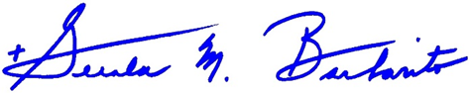

Most Reverend Gerald M. Barbarito
Bishop of Palm Beach

NOTE TO PASTORS: IT IS REQUIRED THAT YOU PUBLISH THIS LETTER IN THE PARISH BULLETIN AS A HALF-PAGE OR FULL-PAGE LETTER THE WEEKEND OF NOVEMBER 5/6, 2022. THE COLLECTION WILL TAKE PLACE NOVEMBER 12/13, 2022. YOU ARE WELCOME TO READ THE LETTER TO PARISHIONERS, POST THIS LETTER ON SOCIAL MEDIA, AND ON YOUR WEBSITE IN ADDITION TO HAVING IT PRINTED IN THE BULLETIN.

