JOIN THE SILVER ROSE PILGRIMAGE
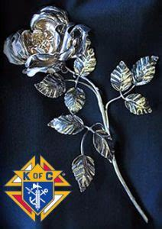
The Silver Rose pilgrimage is coming to North Palm Beach on Monday, August 8 at 7:00 PM in the St. Paul of the Cross Catholic Church, 10970 Jack Nicholas Drive, North Palm Beach, FL 33408.
Everyone is invited to attend the Silver Rose service to honor Our Lady of Guadalupe and add your prayers for the protection of the unborn.
The Silver Rose pilgrimage was originally started by youth, associated with the Knights of Columbus, in 1960 to honor Our Mother Mary when she appeared to Juan Diego, a peasant near Mexico City in 1531.
Since 2001, the Knights of Columbus have led the procession by having the Silver Rose travel throughout the United States, Mexico and Canada (and recently, through many other countries) to pray to Mary for her intercession to protect the unborn.
The Silver Rose will be transported to St. Paul of the Cross by the Florida Chapter of Knights on Bikes, a contingent of motorcycle riders. A short procession will bring the Rose into the Church for a prayer service and viewing of the Rose.
A Class 1 portrait of Our Lady of Guadalupe will be on display and participants will also be able to pledge to defend human life. The pledges will be sent to the Basilica of Guadalupe and presented to Our Lady at a special Mass.
This is a chance for all to pray for the unborn and the families who choose Life.

